**Employee Self Service**

**Project Overview**

This project aims to develop an Employee Self service portal using various technologies such as Visual Studio Code (VS Code), React.js, Node.js, and MySQL. The system includes functionalities like user authentication, display the employee dashboard,Profileview,Leaverequest,Payroll,,Document repository, employee performance & review,Training,Announcement,communication.

**Technologies Used**

* Visual Studio Code (VS Code)
* React.js
* Node.js
* MySQL

**Project Structure**

The project structure is organized as follows:

* **client**: Contains the frontend React.js application code.
* **server**: Contains the backend Node.js application code.
* **database**: Includes the MySQL database schema and sample data.

**## Table of Contents**

**Setup[(Visual Studio Code)] –**

Download link -(<https://code.visualstudio.com/download/Windows>)

**Backend [(Node.js)]-**Download link-(https://nodejs.org/en/download)

**Frontend** (React)

**\*\*Run the backend server:\*\***

**//Terminal**

node server.js

The backend server should be running on **`http://localhost:3001`.**

**### Frontend (React)**

**//Terminal**

npm start

The React app should be running on `**http://localhost:3000`.**

**Features**

**1. Home screen :**

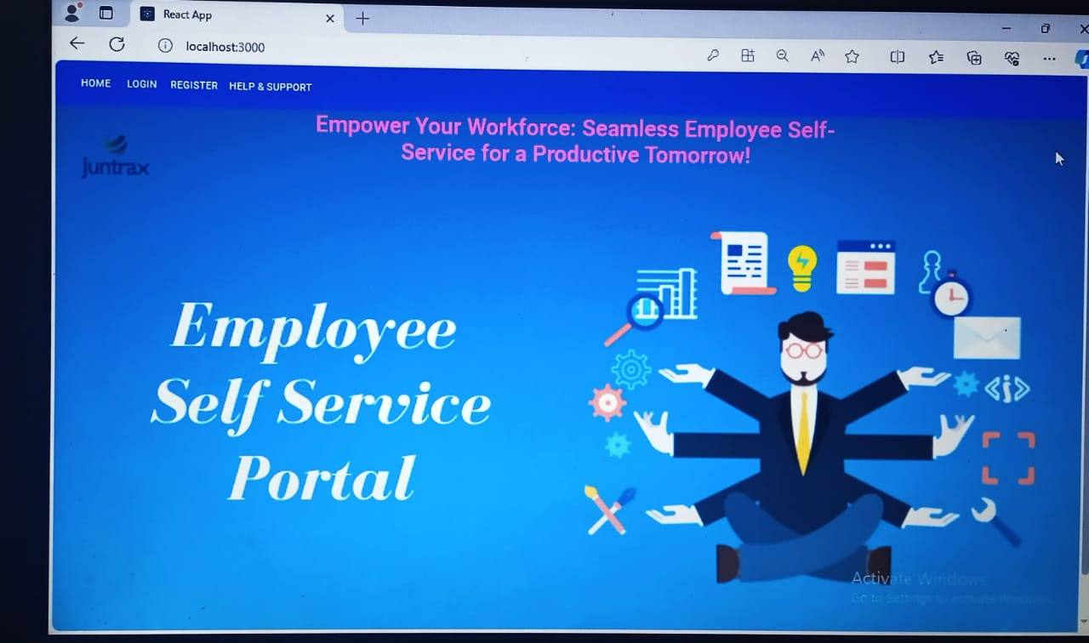

**2. Register Screen:**

Set up role-based access control to ensure that employees can only view and modify information relevant to their roles.

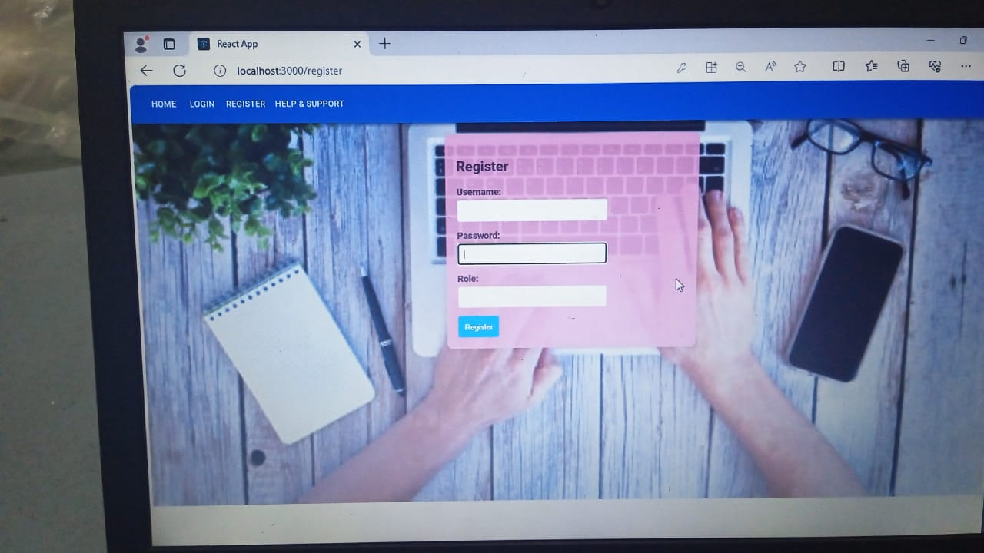

**3. Login Screen:**

Implement a secure login system where employees can authenticate themselves using unique credentials.

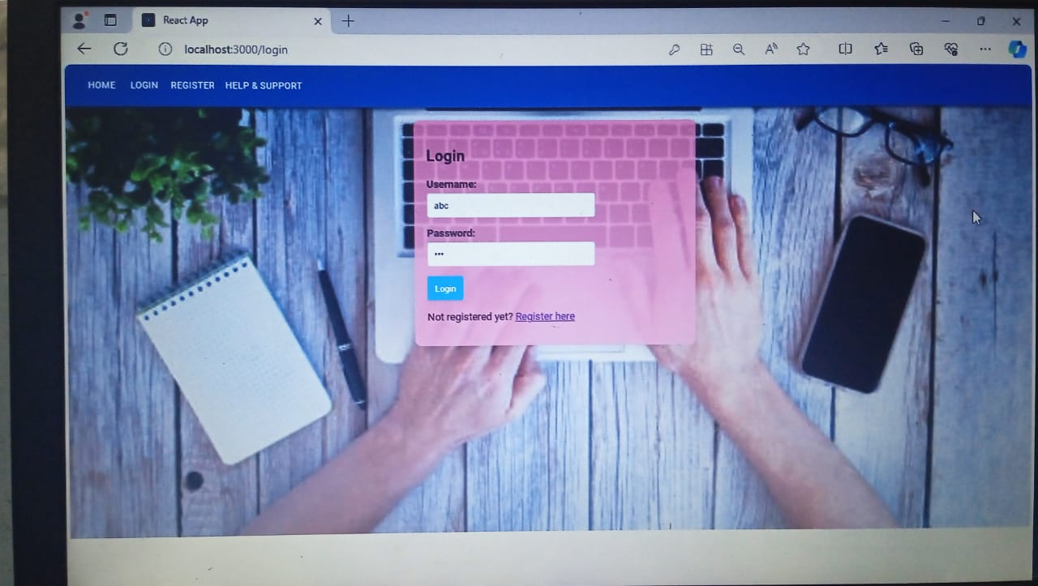

**4. Dashboard:**

Displays a overview of essential information such as upcoming events, leave balances, and announcements.

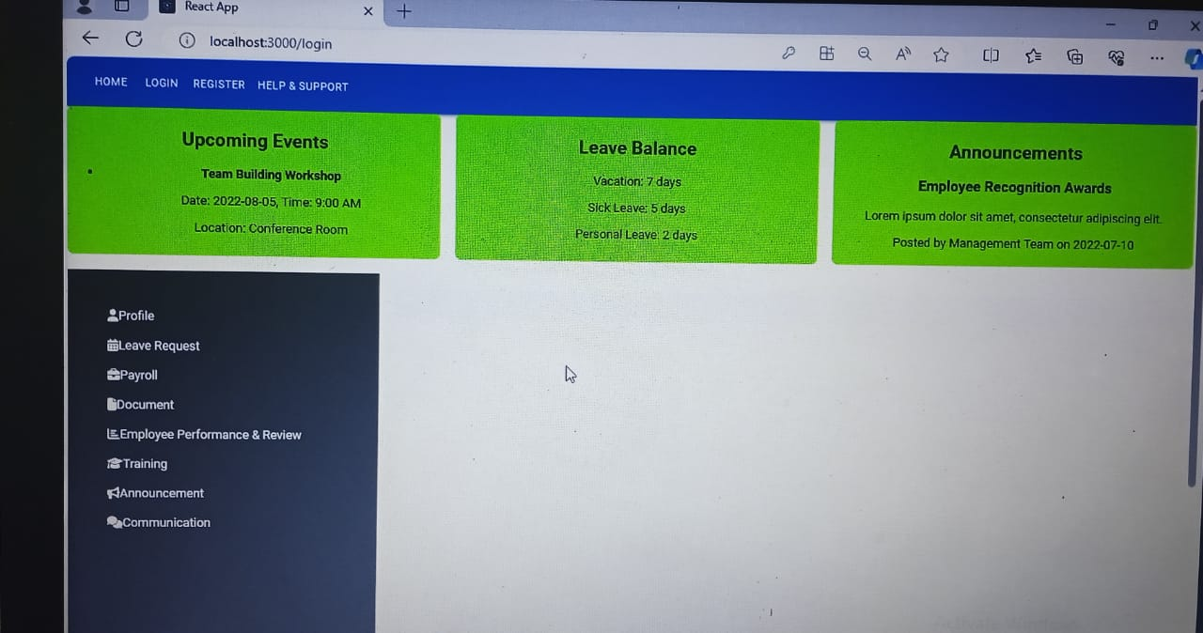

**5. Profile Screen:**

Allow employees to view and update their personal details such as contact information, emergency contacts, and other relevant data.

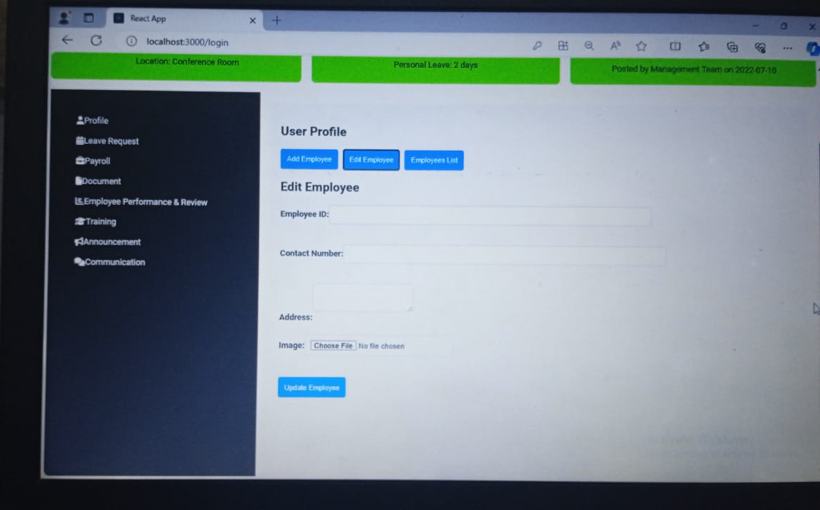

**6. Leave Request:**

A form for employees to submit leave requests, including start and end dates, type of leave, and any additional comments.

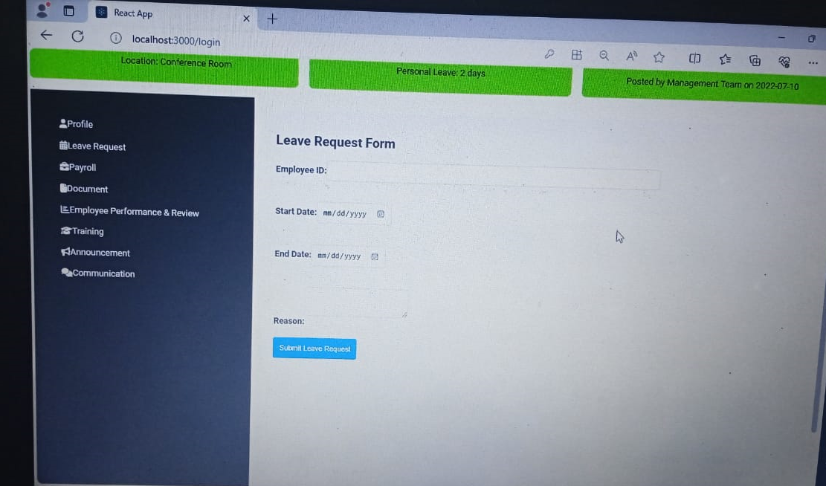

**7. Payroll:**

Provide access to detailed information about salary components.

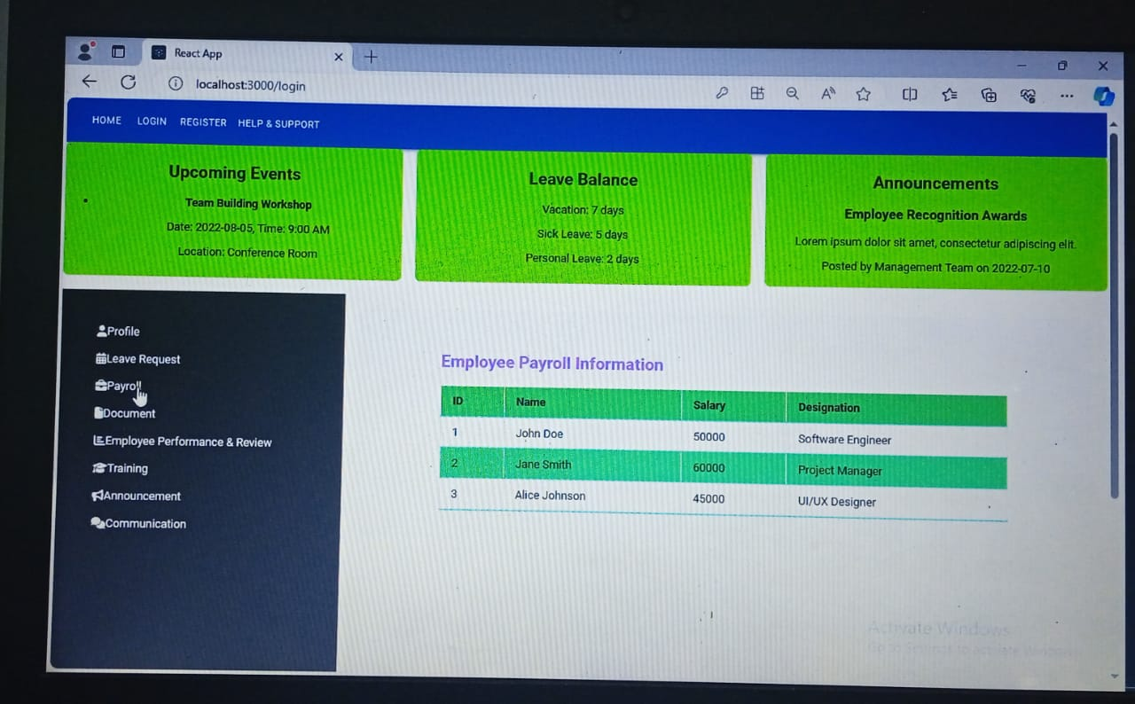

**8. Document Repository:**

Allows employees to upload, view, and download important documents such as resumes, certifications, and company policies.

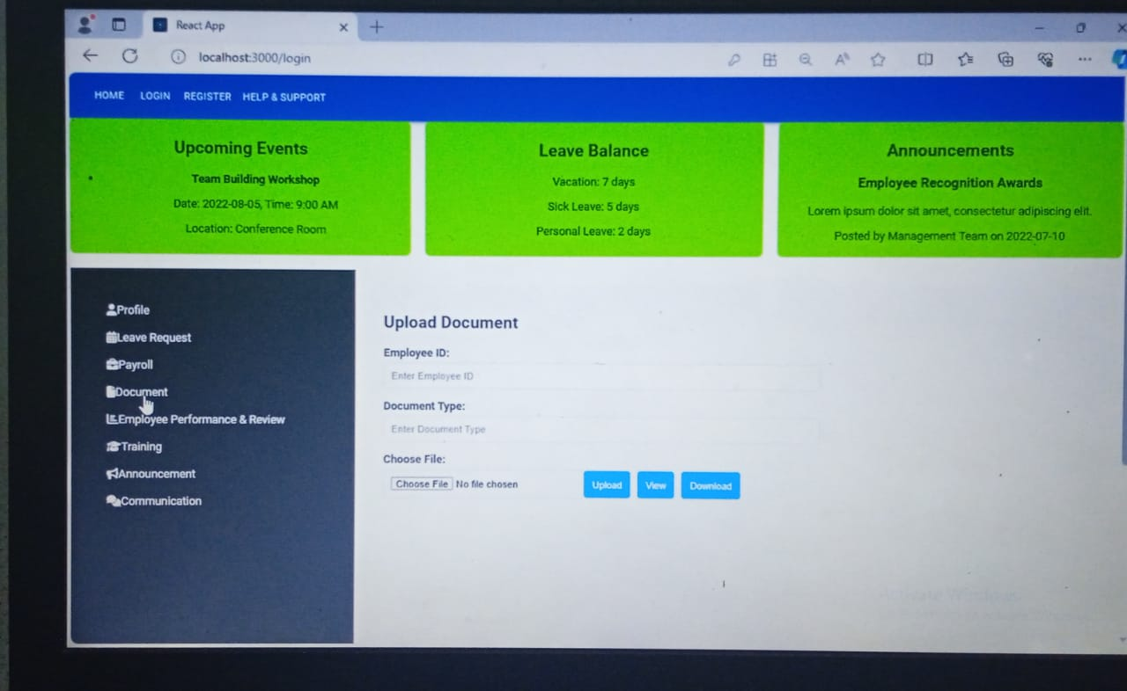

**9.** **Employee performance & Review :**

Displays performance feedback, goals, and appraisal details. Provides a platform for employees to submit self-assessments and feedback.

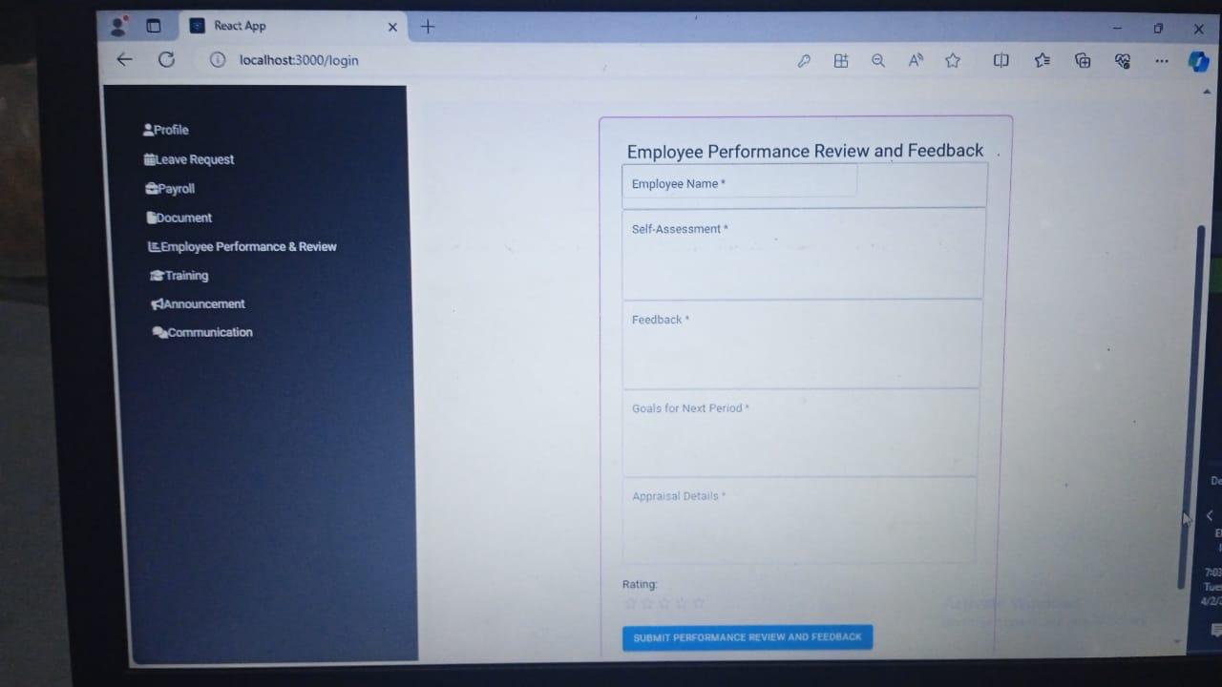

**10.** **Training:**

Lists available training programs, tracks progress, and suggests courses based on individual development plans

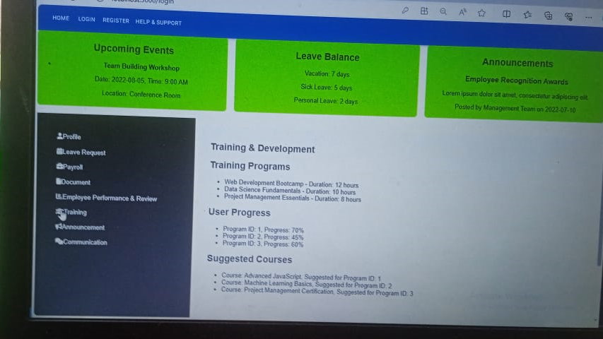

**11. Announcement:**

Displays company-wide announcements, news, and updates.

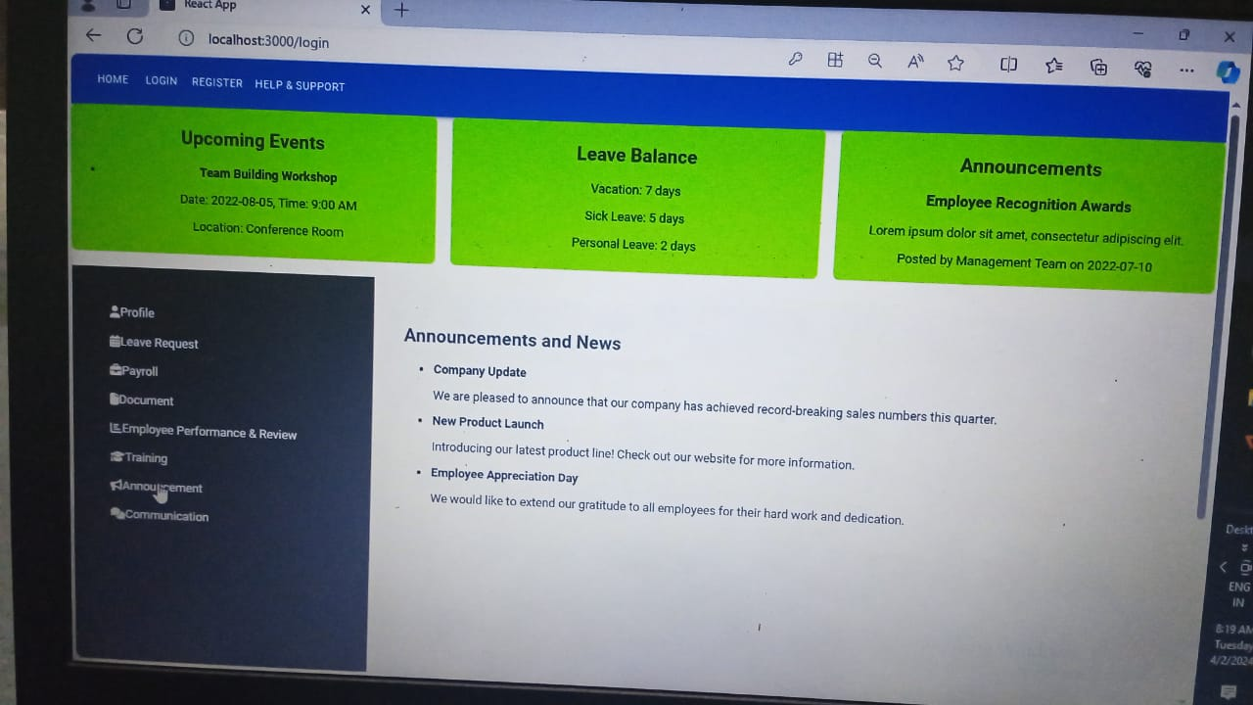

**12.**  **communication:**

Provide options for employees to engage in discussions or forums within the portal.

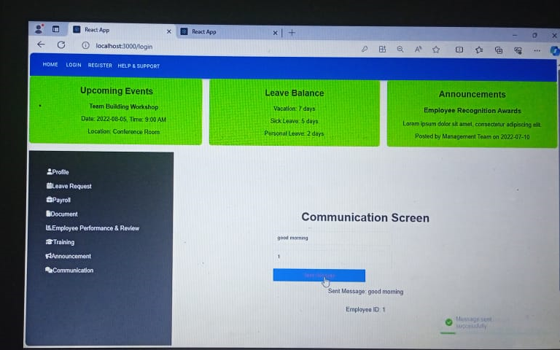

**13**. **help & support :**

Offers resources and contact information for assistance, troubleshooting, and FAQs.

